|  |  |
| --- | --- |
| Team ID | PNT2022TMID13904 |
| Project Name | CONTAINMENT ZONE ALERTING |

**Integrating SendGrid Service**

# SendGrid Integration With Python Code

To send emails from the application we need to integrate the SendGrid Service.

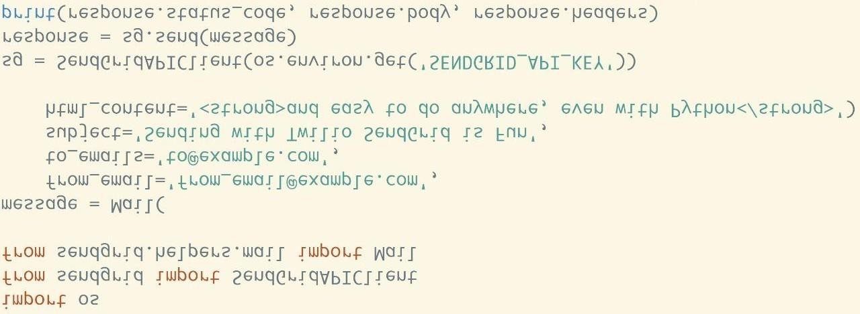

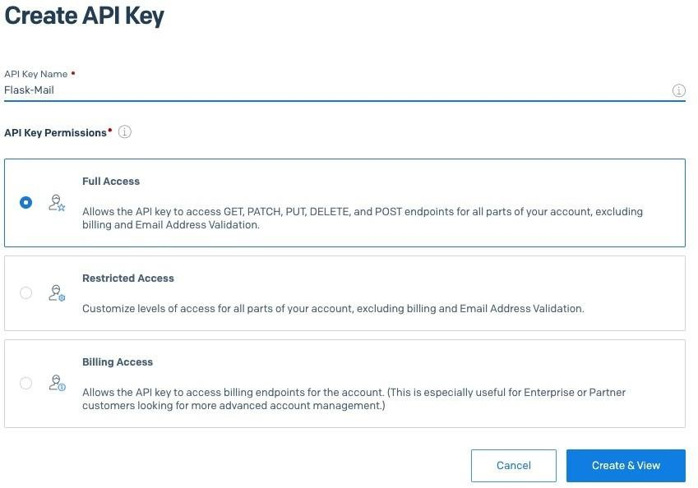

# SendGrid Integration:

import os

from sendgrid import SendGridAPIClient from sendgrid.helpers.mail import Mail message = Mail(

from_email='from_email@example.com', to_emails='to@example.com', subject='Sending with Twilio SendGrid is Fun',

html_content='<strong>and easy to do anywhere, even with Python</strong>') try:

sg = SendGridAPIClient(os.environ.get('SENDGRID_API_KEY')) response = sg.send(message)

print(response.status_code) print(response.body) print(response.headers)

except Exception as e: print(e.message)